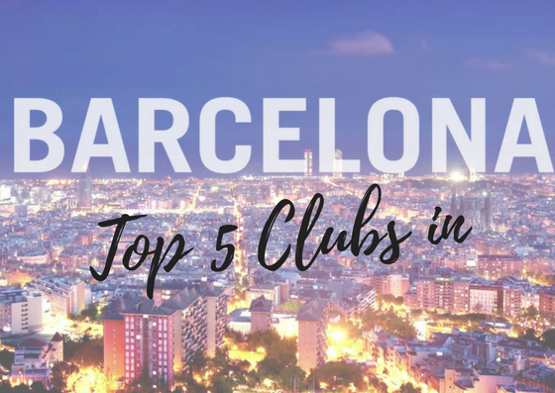
Barcelona may not be the capital of Spain, but is definitely the capital of tourism, nightlife and Spanish experience! Barcelona is full of history, architecture and of course some of the best nightlife venues in the world! If you’re visiting Barcelona, you should definitely try out the nightclubs for the most amazing parties. And for you we have picket the top 5 clubs in Barcelona!
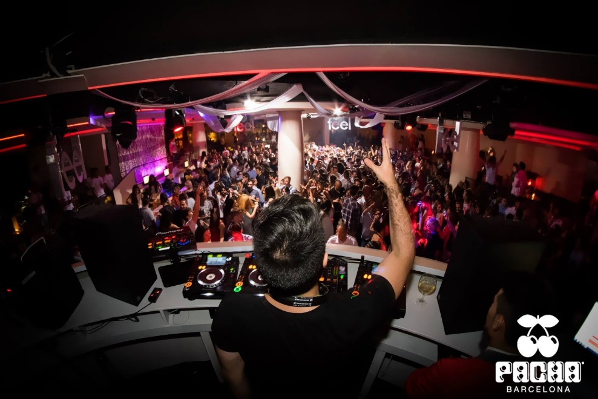
To start our list of the top 5 clubs in Barcelona we have chosen Pacha Barcelona! Pacha Barcelona is a must if you’re in Barcelona! The venue has two indoor rooms and a terrace designed by Pepe López del Hoyo. The interior décor and design is inspired from Ibiza club styles and characterized with white tones and contrast red hues. Each night offers different musical themes! Pacha Barcelona is a juicy, sweet temptation which everyone must experience while in this part of Spain.
After Pacha Barcelona, the second place in our list of the top 5 clubs in Barcelona goes to Catwalk! If you are looking for a spot to chill on or get your groove on, then Catwalk is the place for you. It is one of most spacious clubs in Barcelona as it can accommodate up to 1000 people. The club offers several venues for dancing and also dedicated VIP areas for a special treatment! It is a magnet not only for tourists but from A-Listers too!
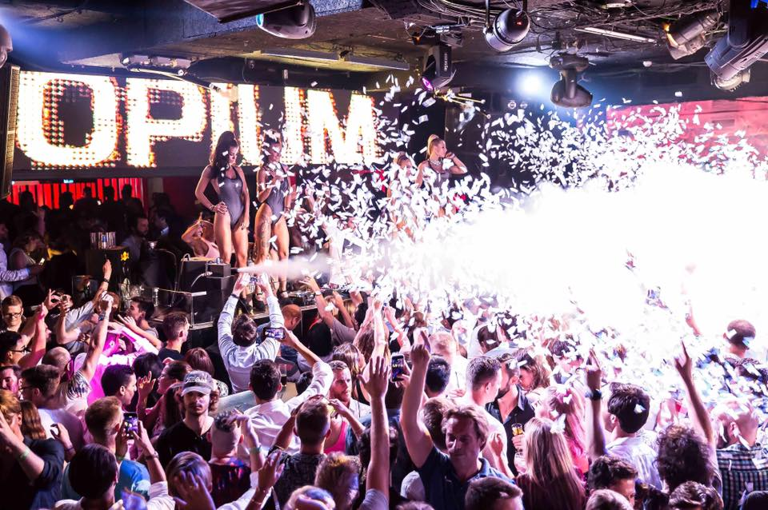
Following our list of the top 5 clubs in Barcelona, say hi to Opium Barcelona! The venue is very exclusive and thus provides excellent unparalleled service to its guests! The party never stops here as Opium Barcelona is opened every night! The interior design includes a modern, avant-garde vibe with 5 VIP areas plus a terrace which offers great view of the Mediterranean Sea. It is definitely in our top list and should be in yours too!
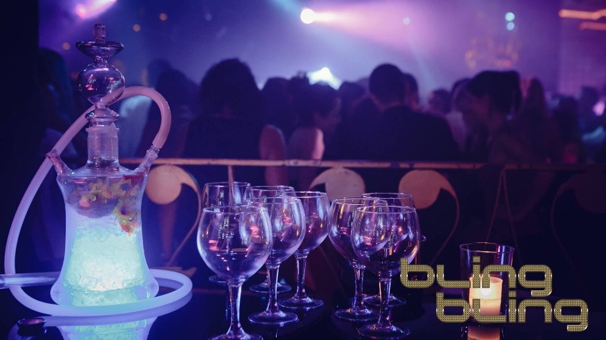
Bling Bling Barcelona has completely changed the essence of nightlife in this city and beyond and totally deserves to be in our list of the top 5 clubs in Barcelona. The first impression you get once you step inside is simple: ELEGANCE! This mega-exclusive Barcelona club is certainly the trendiest and hottest place to be. It offers a full VIP experience to its guests as well and is highly demanded from local, tourists, celebrities and A-Listers! The venue is very exclusive and has a very strict club policy on its guests!
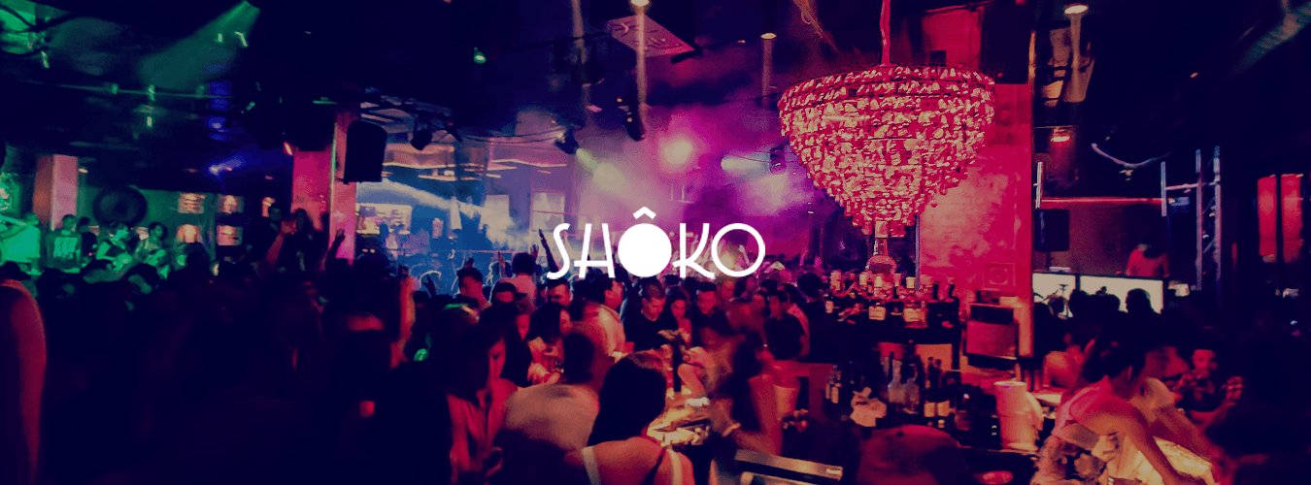
And to sum up our pick of the top 5 clubs in Barcelona, we chose Shoko Barcelona! Shoko Barcelona is the perfect place to be in the city for an amazing nightlife experience. The venue’s interior design and décor is inspired from the attractive Feng-Shui concept. The venue is divided into five main areas, each designed in a unique Japanese style. It is considered as one of the best venues which provides the best of entertainment nights in Barcelona! Shoko Barcelona is definitely your to-go place if you’re looking for an unforgettable night in one of the most amazing cities in the world!
Barcelona has numerous reasons why it should be visited and nightlife is one of the most important reasons! The venue offers a unique and unforgettable experience! Choose your favorite club from our list of the top 5 clubs in Barcelona and plan your next trip in Barcelona now!

